Ok now lets hear some of these "big picture" quotes" of what Srila Prabhupada says.

1) Just like Krsna can be present simultaneously in millions of places, similarly the spiritual master also can be present wherever the disciple wants. A spiritual master is the principle, not the body. Just like a television can be seen in thousands of places by the principle or relay monitoring.(letter may 28 1968)

So in this statement it is very clear that Srila Prabhupada is telling us in this "big picture quote" that the bona fide guru is NOT that physical body, but thru some physical body or NO body he can act just like TV is seen in thousands of places. So this one quote alone destroys the "living guru" nonsense idea.You cannot show me one quote anywhere where he says you need a physically living diksa guru. But here, he clearly tells us that the guru is NOT the body but a principle. Not only does the bona fide guru not need a physical body to deliver Krsna, but he can appear wherever the disciple wants or needs him to. The guru is the principle not the body clearly is telling us that the Divine spirit of God can be experienced thru the disciplic sucession, whether in a physical body or no physical body. Otherwise how could so many thousands of disciples who never saw Prabhupada receive inspiration on a daily basis? And this inspiration goes on even after he physically has left our mortal material vision thru divine sound. And how could these thousands also receive diksa without the presence of a physical body in front of them and the sacred fire? Again, "spiritual master is not the body, but the principle." And that "principle" is what is living not the body. 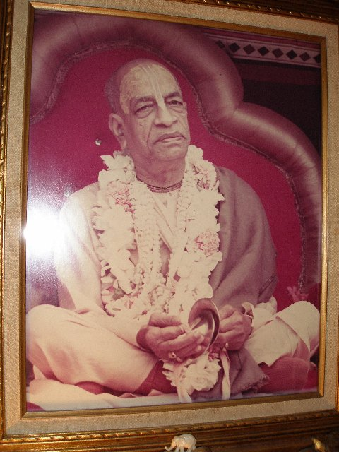
2) a."The potency of transcendental sound is never minimized because the vibrator is absent.(SB 2.9.8)

b.So we should associate by vibration and not by the physical presence. That is real association. (SPL aug 18,1968)

c.Threfore we should take advantage of the vani, not the physical presence, because the vani continues to exist eternally. (Nov 4, 1975)

These three statements clearly show which is more important , the guru in a physical form or the guru in the presence of Transcendental SOUND. And there are many more just like these.
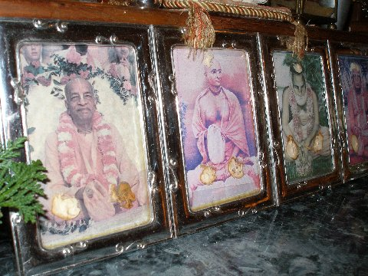

3) 68-04-12.Day Letter: Dayananda
Regarding parampara system: there is nothing to wonder for big
gaps. Just like we belong to the Brahma Sampradaya, so we accept it
from Krishna to Brahma, Brahma to Narada, Narada to Vyasadeva,
Vyasadeva to Madhva, and between Vyasadeva and Madhva there is a big
gap. But it is sometimes said that Vyasadeva is still living, and
Madhva was fortunate enough to meet him directly. In a similar way, we
find in the Bhagavad-gita that the Gita was taught to the sungod, some
millions of years ago, but Krishna has mentioned only three names in
this parampara system--namely, Vivasvan, Manu, and Iksvaku; and so
these gaps do not hamper from understanding the parampara system. We
have to pick up the prominent acaryas, and follow from him. There are
many branches also from the parampara system, and it is not possible
to record all the branches and sub-branches in the disciplic
succession. We have to pick up from the authority of the acharya in
whatever sampradaya we belong to.

So in this letter again we find Srila Prabhupada explaining the "big picture". Your lost in some city, but if you know where you should be, you just ask people, especially those who would know, how do I get to this place/person? Once Prabhupada disappears to our mortal vision, this is not a problem for future generations, because they only have to pick up the most recent prominent acarya and follow him.And if he is prominent, he will NOT be hard to find. Very simple and very clearly explained. Srila Prabhupada is the most recent prominent acarya, therefore we must follow him for that alone is sufficient for our spiritual lives. Even Christians today can become disciples of Christ if they follow him and his teachings--Prabhupada
clearly explained this in Seattle back in 1968. But you will never find a Christian priest today claiming he has been ordered by Jesus to accept new disciples. But the priests DO accept and teach new disciples in the NAME of Jesus. And everyone accepts and understands it is JESUS who is the one who is taking their sins, and delivering them.

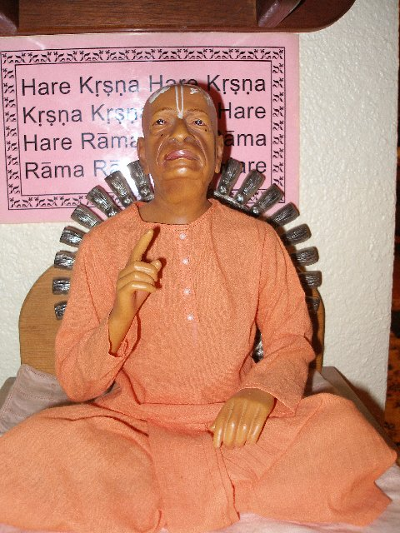
4) Reporter (2): What will happen to the movement in the United States
when you die?
Prabhupada: I will never die.
Devotees: Jaya! Hari bol! (laughter)
Prabhupada: I shall live for my books, and you will utilize.
Reporter (2): Are you training a successor?
Prabhupada: Yes, my Guru Maharaja is there. Where is my photo of Guru
Maharaja? I think... Here is.

So again here Srila Prabhupada explains the spiritual master is the principle, not the body idea of what and who is Guru. Otherwise how do you explain how the movement can go on since he is telling us he will never die, but live from his books which all of us will utilize-eternally if need be. The problem arises when the foolish neophyte disciples "kill the guru" by trying to take his place. And so ends the disciplic sucession,at that point because nobody can become guru unless he is authorized and qualified.
The movement will continue, if for nothing else, simply because of Prabhupadas books And in the above, he says, the successor is his guru maharaj (not even him, taking the humble position) And Why is Srila Bhaktisiddhanta Maharaj the successor? Because he is the most recent prominent link in the param para. Our Prabhupada is just being humble here and giving all credit for the continuance to his guru maharaj.

5) 760816rc.bom Conversations
Why this Gaudiya Matha failed? Because they tried to become
more than guru. He, before passing away, he gave all direction and
never said that "This man should be the next acarya." But ... the
failure. They never thought, "Why Guru Maharaja gave us instruction so
many things, why he did not say that this man should be acarya?" They
wanted to create artificially somebody ... with common sense that if
Guru Maharaja wanted to appoint somebody as acarya, why did he not
say? He said so many things, and this point he missed? The real point?
And they insist upon it. They declared some unfit person to become
acarya. Then another ....

This is a very clear explanation of what NOT to do after our acarya leaves our vision. If you want to
fail, then appoint, elect, create an acarya board, etc or whatever you fantasize, but none of it will work.
Why not? Because none of these things were the order of Srila Prabhupada.
Also important in this statement is the idea that Srila Bhaktisiddhanta Maharaj would not leave this world AND leave the continuation of his Gaudiya matha UNCLEAR to his disciples. And because Srila Prabhupada is bringing up this point, then why would HE also leave the continuation of HIS movement UNCLEAR?? Prabhupada never left anything unclear and would ask his disciples several times in a conversation --"Is that clear"? So this most important thing, "THE REAL POINT" how the movement would go on, he left --THIS UNCLEAR?? What an absurd idea and proposition.

6)PKP PHALGUNA KRISHNA PANCAMI
23. If everyone just initiates then there will only be a
contradictory result. As long as it goes on there will be only
failure.

This is what we have going on right now--anybody who can gather by threats, by politics or bribes of prasadam, enough votes from the GBC, he or she can be elected as GURU of iskcon. Wheres the "tradition" for this action? So the Gaudiya matha failed for this reason. Failed means not having some buildings to "show" a Deity, but failed means- the vigorous preaching activity stopped. And why did the preaching stop?
Because men who were less than neophytes or kanistha at best, occupied the seat meant for Uttama adhikaris. When people win the lottery, most of the time, this huge increase in wealth ruins their personal lives. Why? Because they are not ready for it, nor know how to handle Laxsmi, so because their hearts are unclean, this wealth and prestige takes them down the road to hell. Where is the magnificent original 11 today? This is why Srila Prabhupada warned his Godbrothers and us his disciples and followers today, NOT
to take this path of "thinking" we are qualified to take on karma and deliver souls back to Godhead without
the qualifications. The result is only FAILURE,as he says, as we have sadly seen.

7) ►74-04-28.Rup Letter: Rupanuga
..He never recommended anyone to be
acarya of the Gaudiya Math. But Sridhara Maharaja is responsible for
disobeying this order of Guru Maharaja, and he ... the acarya is being
changed three times a year. Therefore we may not commit the same
mistake in our ISKCON camp. Actually amongst my Godbrothers no one is
qualified to become acarya....

How can Srila Prabhupada make this any more clear?? Only personal ambition
can cloud the proper understanding of these crystal clear words from our Acarya.

8) 770528me.vrn
Satsvarupa: By the votes of the present GBC. Then our next question
concerns initiations in the future, particularly at that time when
you're no longer with us. We want to know how first and second
initiation would be conducted.
Prabhupada: Yes. I shall recommend some of you. After this is settled
up, I shall recommend some of you to act as officiating acaryas.
Tamala Krsna: Is that called rtvik-acarya?
Prabhupada: Rtvik, yes.

So here a one pointed question is asked of Srila Prabhupada-what will happen in the future
when you are no longer with us?? He clearly states, he wants disciples to act, just like priests
do in the Christian religion, as brahmanas do in the Ramanuja and Madhva sampradayas today, as representatives of him the Acarya of the Hare Krsna Movement, called iskcon.
This is called ritviks or priests. And these ritviks are the same devotees who were doing the exact same
activity as they were doing before Prabhupada called them "ritviks" in this conversation. The only difference
is that nobody knew or heard of this word-ritvik at that time. The actions of the ritviks were to be the exact same actions they were doing before when initiating new candidates all over the world on BEHALF of Srila Prabhupada.
The only difference now is that eveyone knew what their TITLE was--a ritvik priest who acts on behalf of the Acarya. That is the only difference.
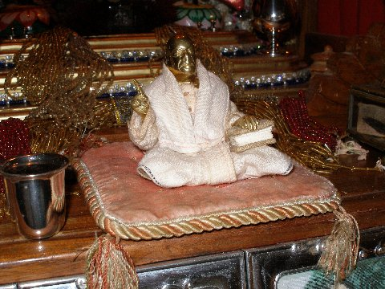

9) 67-02-11.Kir Letter: Kirtanananda
I wish that each and every Branch shall keep their
independent identity and cooperate keeping the Acarya in the centre.
on this principle we can open any number of branches....

This is a very instructive letter given to us because Prabhupada is not only telling us how to
continue his movement spiritually, but also how to organize it on the mundane level in relation
to government and financial problems which could arise in the future. If the whole Hare Krsna movement
was consolidated as one huge corporation, then the failure of one could bring financial ruin to all temples.
Therefore, this insturction is given. Practical and spiritual all in one. Maximum solution minimum words.
He never said each temple could have several acaryas/gurus because that is what happened to his old
Gaudiya matha, and they failed. So why would he duplicate a failed policy in his movement?
He didnt and thats why we have this instruction. And not only that, but the movement would GROW
by this method as more temples could be added to the movement IF the acarya was in the center.

10) Madhya 24.330
.... When one has attained the topmost position of
maha-bhagavata, he is to be accepted as a guru and worshiped exactly
like Hari, the Personality of Godhead. Only such a person is eligible
to occupy the post of a guru.

How can anybody but an uttama adhikari even think of becomming guru?
Only if he or she is a CHEATER.
We have all read this quote, but what "gurus" in iskcon follows it? None of them. Another side point
is that an actual bona fide guru, pure devotee NEVER really wants this post, and has to be asked or demanded to take up the position.
Jesus Christ asked Krsna to remove this cup(austerity) from him. Srila Prabhupada had Srila Bhaktisiddhanta Maharaj appear several times to him in dreams to take sannyasa and take up this mission of preaching. Prabhupada said he was "horrified", because why? He KNEW, just as did Christ, the responsibility connected to this task. But for foolish devotees who have no idea of the mountain of sins they will have to incur and suffer for, and who dont possess the spiritual power to nullify these sins, for them, all they "see" is "profit, adoration ,and distinction" as gurus--all massive pitfalls on the road to Vaikuntha.
So these motivated individuals bypas this important instruction and like King Paundraka did, "assume" the title of acarya, by falsely "thinking" they are qualified.

11) 77-07-09.All Letter: All G.B.C., All Temple Presidents
In the past Temple Presidents have written to Srila Prabhupada
recommending a particular devotee's initiation. Now that Srila
Prabhupada has named these representatives,[ritviks] Temple Presidents may
henceforward send recommendation for first and second initiation to
whichever of these eleven representatives are nearest their temple.
After considering the recommendation, these representatives may accept
the devotee as an initiated disciple of Srila Prabhupada by giving a
spiritual name, or in the case of second initiation, by chanting on
the Gayatri thread, just as Srila Prabhupada has done. The newly
initiated devotees are disciples of His Divine Grace A.C.
Bhaktivedanta Swami Prabhupad, the above eleven senior devotees acting
as His representative. After the Temple President receives a letter
from these representatives giving the spiritual name or the thread, he
can perform the fire yajna in the temple as was being done before. The
name of a newly initiated disciple should be sent by the
representative who has acceted him or her to Srila Prabhupada, to be
included in His Divine Grace's "Initiated Disciples" book.
So in conclusion to this paper, we have included just one of many documents in letter form
which Srila Prabhupada sent out to his leading disciples worldwide regarding how to continue
the process of initiations after he departed from us. It is clear english, and anybody who reads
this letter and several others like it, will honestly conclude that this DOCUMENT is very important as to how the Hare Krsna Movement would continue. This document is only one way Srila Prabhupada made the point
the REAL POINT (as mentioned above) how he wanted things to continue. He was to be the acarya, and he would continue to initiate into the future new disciples after he was physically gone. I have included the above quotes to substantiate this final document. The above mentioned quotes give the principle of guru tattva, and this letter gives the physical details of HOW it was to be done.

12) Madhya 6.109 The Liberation of Sarvabhauma Bhattacary
In this verse from Srimad-Bhagavatam (11.22.4), the Supreme
Personality of Godhead explains that His illusory energy can perform
the impossible; such is the power of the illusory energy. In many
cases philosophical speculators have covered the real truth and have
boldly set forth false theories. In ancient times philosophers like
Kapila, Gautama, Jaimini, Kanada and similar brahmanas propounded
useless philosophical theories, and in modern days so-called
scientists are setting forth many false theories about the creation,
backed up by seemingly logical arguments. This is all due to the
influence of the Supreme Lord's illusory energy. The illusory energy,
therefore, sometimes appears correct because it is emanating from the
Supreme Correct. To avoid the very bewildering illusory influence, one
must accept the words of the Supreme Personality of Godhead as they
are. Only then can one escape the influence of the illusory energy.

Hare Krsna
Damaghosa das

