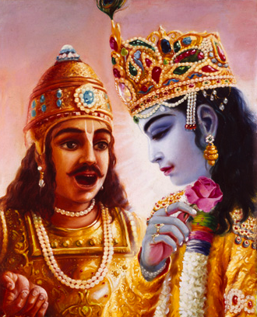

**"Therefore means... *åtvik* yes!!!"**